OSFL StarRez Check In Process
Go to this website:
https://utk.starrezhousing.com/StarRezWeb

Click on the UTK - Staff SSO Login
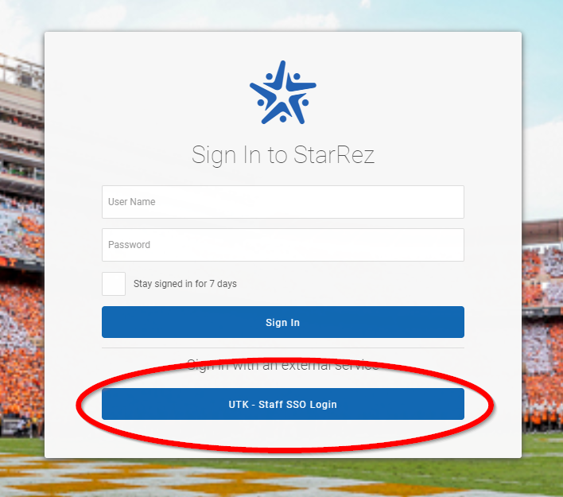

Input your NetID and Password:
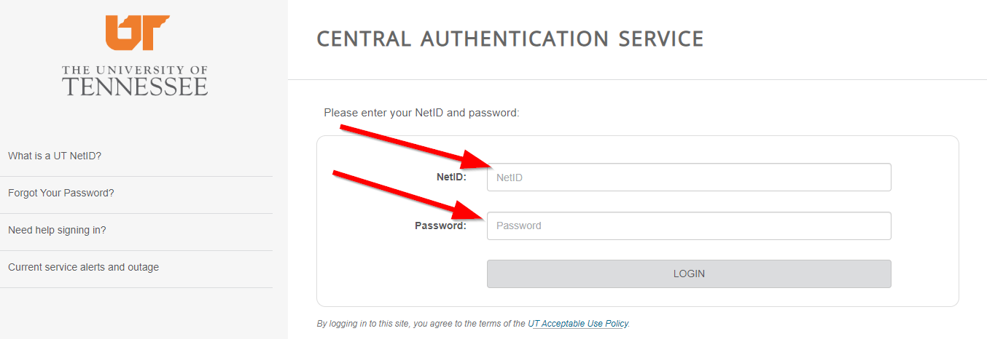
Follow the prompts for Two Factor Authentication, if they show for you.

Once in StarRez click on the Main icon on the Left Menu.
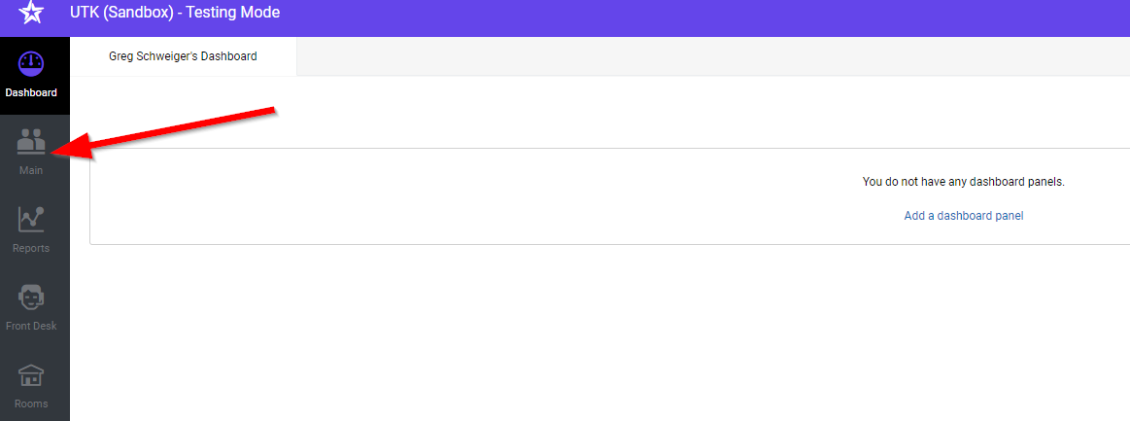

Next, click on the Entry Status dropdown and select “Reserved”
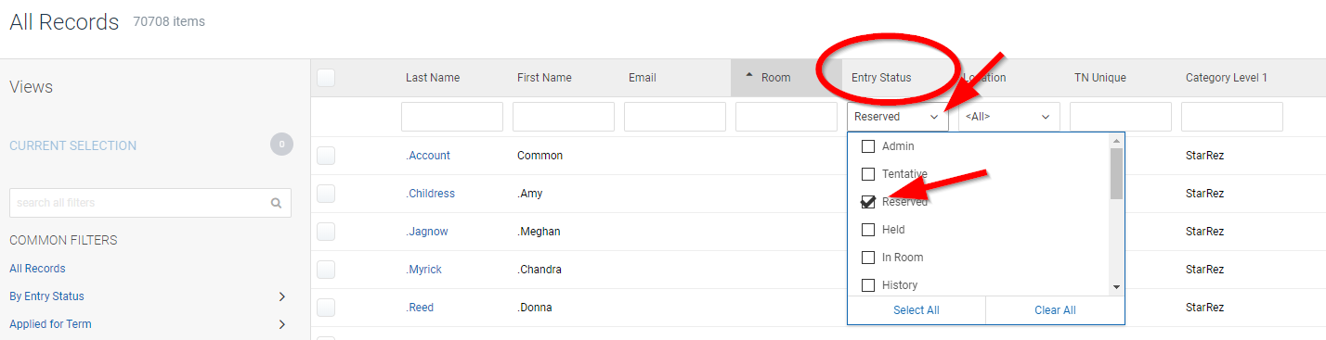
Then click on the Location dropdown and select Your House from the list.

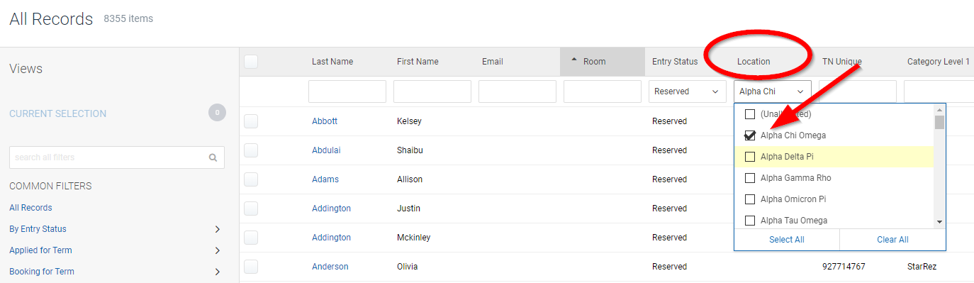
This will give you a list of all the resident for Your House. You can then click on their Name (blue linked). This will bring up their record.
Check that they are Health Compliant. There should be a checked box if they are. If they are not, they will need to be referred to the Student Health Center.

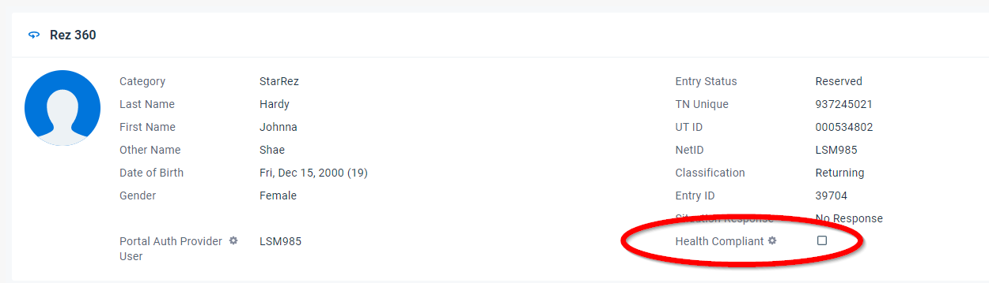

Next go the left menu and click on the Custom Fields menu option.

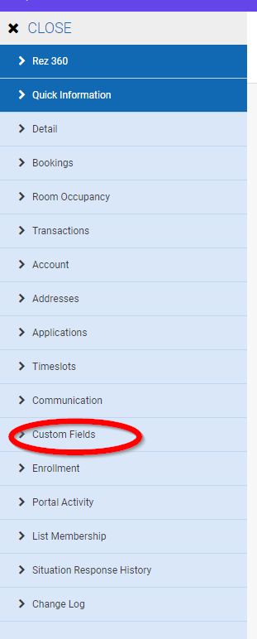

In the window at the right, scroll to the bottom and verify if they have signed the 2020 Addendum. The box will be checked if they have. If they have not, please refer them to their email where they should have instructions on signing the addendum.
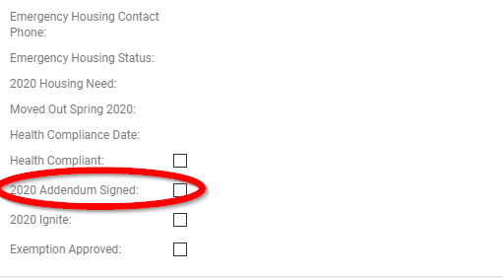

Once they are determined to be Health Compliant and have sign the addendum, they can be checked in. If you are still in the Custom Fields area, click on the Rez 360 link at the top of the Left Menu.
Next double check the Room assignment and click on CHECK IN.
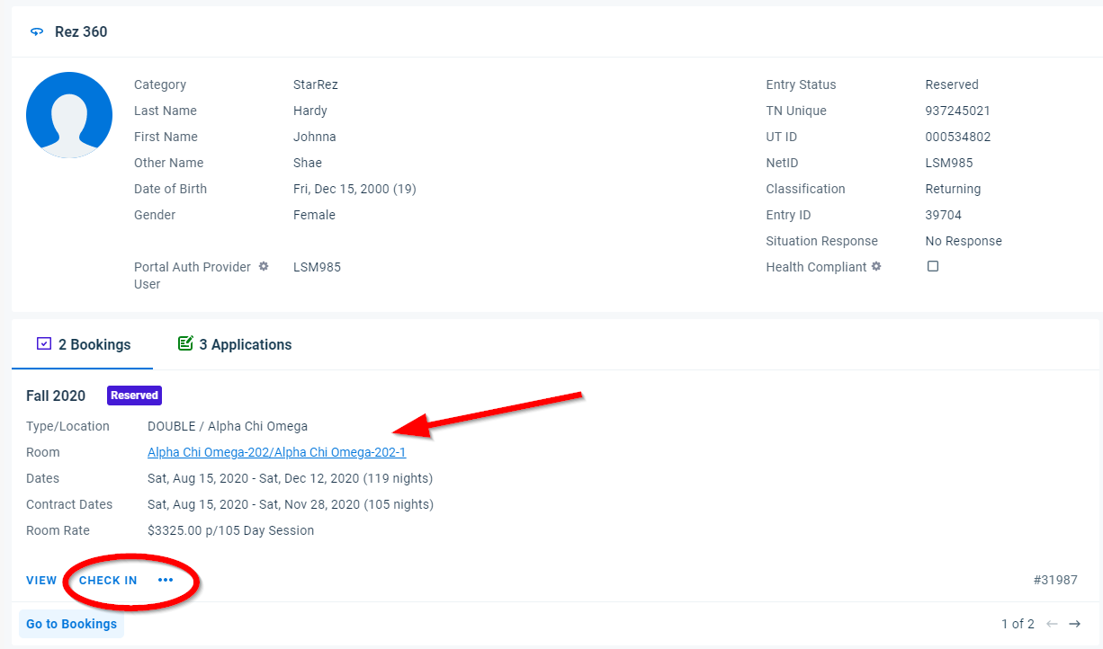

Then Click OK on the Booking Dialog box.
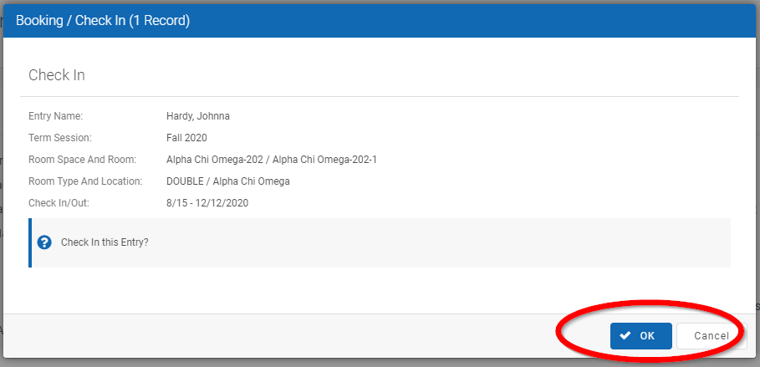
You will then be prompted about Check in Date Not Today. Click Fix to proceed.
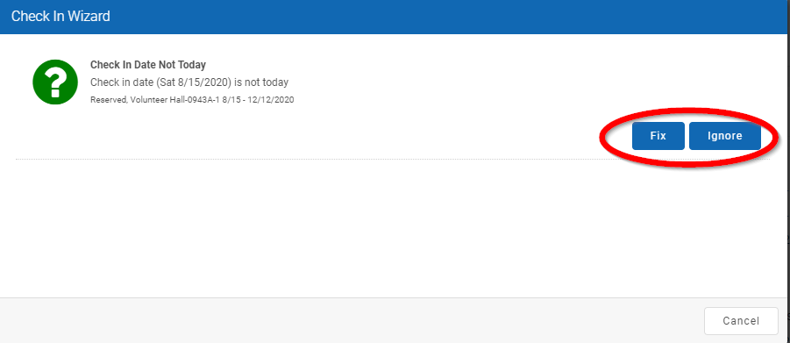
You have now successfully checked in the resident.

To continue to the next resident click on the Close link at the top of the Left Menu.

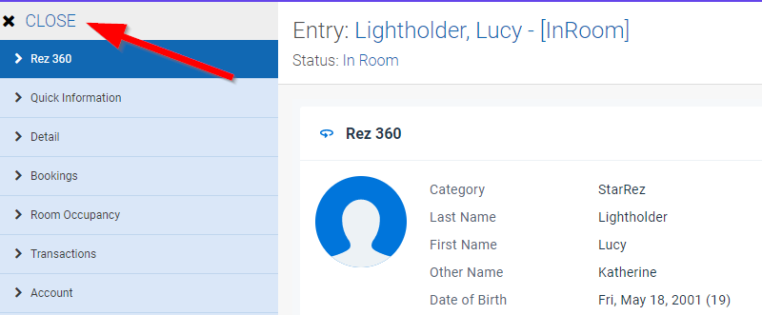
This will bring you back to your list of Residents where you can repeat the process.
