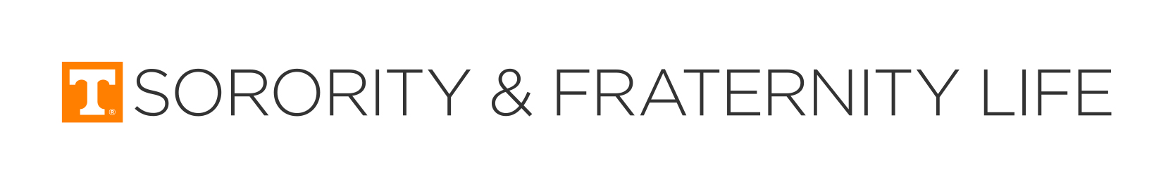
_____________________ FRATERNITY/SORORITY ROOM _______________________________
RESIDENT ROOM CONDITION AND CLEARANCE FORM

PLEASE PRINT
Last Name ______________________________ First Name _______________________UT ID________________________
Permanent Address________________________________________________________Cell Phone____________________ City State Zip
Parent/Guardian Name _________________________________________________ Home Phone _____________________

ITEM | CHECK-IN | CHECK-OUT | CHARGE
Main Door (front and back)
Bed/ Bunkbed/Loft (circle one)
Mattress
Desk
Desk Chair
Chair
Ottoman
Bookcase/Shelves
Chest
Closet
Ceiling and Light
Smoke Alarm
Walls
Floor
Window/Screens
Venetian Blinds
Air Conditioner/Heat Unit
Key and Lock (Recore)
Microfridge
Glass turntable
1 or 2 Ice Trays
1 Ice Scraper
2 Refrigerator Shelves
Other
Total Charges

By signing this form you agree to the condition of the room and furnishings as noted on this form. It is in your best interest to make sure that every item is carefully checked. You are responsible for any damages or loss of any item. Upon check-out, you are responsible for all charges listed above. Please read the important safety information on the back of this form.

CHECK-IN CHECK-OUT
_________________________________________ ______________ ____________________________________________ ______________

Resident Signature Date Resident Signature Date
__________________________________________________ _________________ ______________________________________________________ _________________

House Manager Signature Date Room Checked House Manager Signature Date Room Checked

__________________________ _______________________________ Key Returned: Yes_____ No_____ Code____________________

Key Code Issued Date Key Issued - HM Initials
_____________________________________________________ ___________________
Housing Corp. Representative Signature Date

Updated 10-30-17

UNIVERSITY OF TENNESSEE
SAFETY AND SECURITY AWARENESS AGREEMENT

The Fraternity/Sorority Housing Corporation and the University of Tennessee, Knoxville are actively concerned about the safety of students living on campus. We provide services designed to establish a safe and secure living environment in the fraternity/sorority facilities. These services heavily rely upon your support and you are principally responsible for your own safety. Please read through the following safety-related expectations which apply to all residents living in a fraternity or sorority facility.

- LOCK YOUR DOOR. The most important thing you can do to protect yourself and your property is to keep your door locked at all times. Past experience has demonstrated this is the number one deterrent of crimes occurring in your room.

- DO NOT PROP OPEN EXIT DOORS.

- NEVER LET AN UNESCORTED STRANGER INTO THE HOUSE AS YOU ENTER OR LEAVE. If you are not a hundred percent sure the person trailing in behind you is a member of the organization, do not let that person in.

- REPORT UNESCORTED STRANGERS TO YOUR HOUSE DIRECTOR IMMEDIATELY.

- ESCORT YOUR GUESTS AT ALL TIMES.

- REPORT LOST KEYS TO THE HOUSE DIRECTOR/CORPORATION IMMEDIATELY.

- NEVER LEND YOUR KEY OR DOOR CODE TO A GUEST, ROOMMATE, OR OTHER NON-MEMBER.

- DO NOT TAMPER WITH YOUR SMOKE DETECTOR. Report any problems with your smoke detector to the house director.

- Follow all policies outlined in the Guidebook/Calendar for University Housing.

You play an important role in making our fraternity/sorority facilities a safe environment in which to live. Your signature on the front of this form at check-in indicates you have read these responsibilities and agree to uphold them. Failure to adhere to any of the above mentioned policies can result in disciplinary action.

